1. Write a C program to simulate the following CPU scheduling algorithm to find turnaround time and waiting time.
b) SJF (Preemptive and Non preemptive)
c) Priority Scheduling (Preemptive and Non preemptive)
Do comparative analysis of all the algorithms by giving data and identify which algorithm is optimal.
SJF Non-preemptive
#include<stdio.h>
int main()
{
int n,i,j,time=0,small;
int at[20],bt[20],ct[20],tat[20],wt[20],done[20]={0};
float avgtat,avgwt,ttat=0,twt=0;
printf("Enter number of processes: ");
scanf("%d",&n);
for(i=0;i<n;i++)
{
printf("Enter AT and BT for P%d: ",i+1);
scanf("%d%d",&at[i],&bt[i]);
}
for(i=0;i<n;i++)
{
small=-1;
for(j=0;j<n;j++)
{
if(done[j]==0 && at[j]<=time)
{
if(small==-1 || bt[j]<bt[small])
small=j;
}
}
if(small==-1)
{
time++;
i--;
continue;
}
time+=bt[small];
ct[small]=time;
tat[small]=ct[small]-at[small];
wt[small]=tat[small]-bt[small];
done[small]=1;
}
for(i=0;i<n;i++)
{
ttat=ttat+tat[i];
twt=twt+wt[i];
}
avgtat=ttat/n;
avgwt=twt/n;
printf("\nP\tAT\tBT\tCT\tTAT\tWT\n");
for(i=0;i<n;i++)
printf("P%d\t%d\t%d\t%d\t%d\t%d\n",i+1,at[i],bt[i],ct[i],tat[i],wt[i]);
printf("Avarage TAT:%f",avgtat);
printf("Avarage WT:%f",avgwt);
return 0;
}
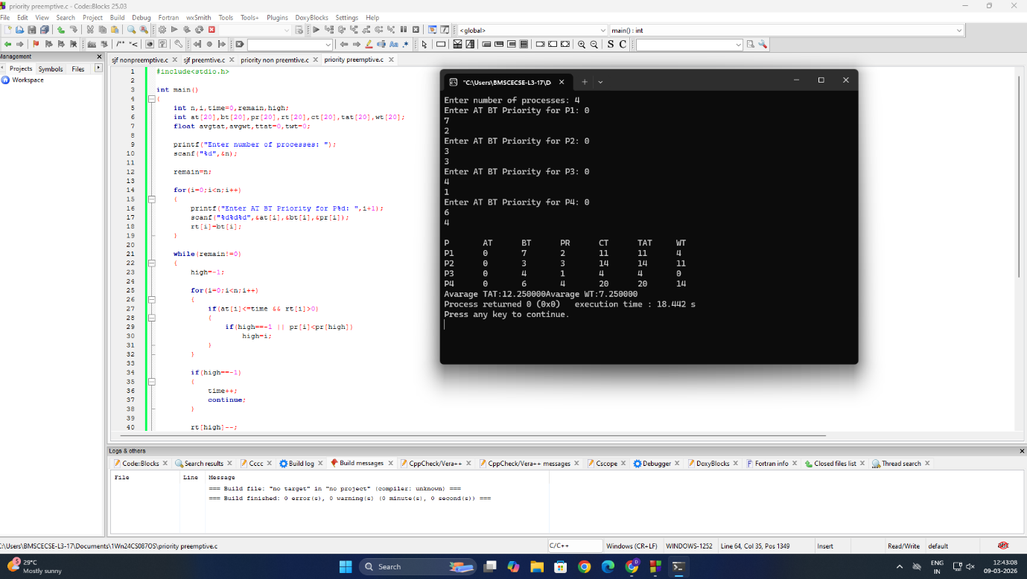

SJF Preemptive
#include<stdio.h>
int main()
{
int n,i,time=0,remain,small;
int at[20],bt[20],rt[20],ct[20],tat[20],wt[20];
float avgtat,avgwt,ttat=0,twt=0;
printf("Enter number of processes: ");
scanf("%d",&n);
remain=n;
for(i=0;i<n;i++)
{
printf("Enter AT and BT for P%d: ",i+1);
scanf("%d%d",&at[i],&bt[i]);
rt[i]=bt[i];
}
while(remain!=0)
{
small=-1;
for(i=0;i<n;i++)
{
if(at[i]<=time && rt[i]>0)
{
if(small==-1 || rt[i]<rt[small])
small=i;
}
}
if(small==-1)
{
time++;
continue;
}
rt[small]--;
time++;
if(rt[small]==0)
{
remain--;
ct[small]=time;
tat[small]=ct[small]-at[small];
wt[small]=tat[small]-bt[small];
}
}
for(i=0;i<n;i++)
{
ttat=ttat+tat[i];
twt=twt+wt[i];
}
avgtat=ttat/n;
avgwt=twt/n;
printf("\nP\tAT\tBT\tCT\tTAT\tWT\n");
for(i=0;i<n;i++)
printf("P%d\t%d\t%d\t%d\t%d\t%d\n",i+1,at[i],bt[i],ct[i],tat[i],wt[i]);
printf("Avarage TAT:%f",avgtat);
printf("Avarage WT:%f",avgwt);
return 0;
}



Priority scheduling Non-preemptive

#include<stdio.h>
int main()
{
int n,i,j,time=0,high;
int at[20],bt[20],pr[20],ct[20],tat[20],wt[20],done[20]={0};
float avgtat,avgwt,ttat=0,twt=0;
printf("Enter number of processes: ");
scanf("%d",&n);
for(i=0;i<n;i++)
{
printf("Enter AT BT Priority for P%d: ",i+1);
scanf("%d%d%d",&at[i],&bt[i],&pr[i]);
}
for(i=0;i<n;i++)
{
high=-1;
for(j=0;j<n;j++)
{
if(done[j]==0 && at[j]<=time)
{
if(high==-1 || pr[j]<pr[high])
high=j;
}
}
if(high==-1)
{
time++;
i--;
continue;
}
time+=bt[high];
ct[high]=time;
tat[high]=ct[high]-at[high];
wt[high]=tat[high]-bt[high];
done[high]=1;
}
for(i=0;i<n;i++)
{
ttat=ttat+tat[i];
twt=twt+wt[i];
}
avgtat=ttat/n;
avgwt=twt/n;
printf("\nP\tAT\tBT\tPR\tCT\tTAT\tWT\n");
for(i=0;i<n;i++)
printf("P%d\t%d\t%d\t%d\t%d\t%d\t%d\n",
i+1,at[i],bt[i],pr[i],ct[i],tat[i],wt[i]);
printf("Avarage TAT:%f",avgtat);
printf("Avarage WT:%f",avgwt);
return 0;
}



Priority scheduling Preemptive

#include<stdio.h>
int main()
{
int n,i,time=0,remain,high;
int at[20],bt[20],pr[20],rt[20],ct[20],tat[20],wt[20];
float avgtat,avgwt,ttat=0,twt=0;
printf("Enter number of processes: ");
scanf("%d",&n);
remain=n;
for(i=0;i<n;i++)
{
printf("Enter AT BT Priority for P%d: ",i+1);
scanf("%d%d%d",&at[i],&bt[i],&pr[i]);
rt[i]=bt[i];
}
while(remain!=0)
{
high=-1;
for(i=0;i<n;i++)
{
if(at[i]<=time && rt[i]>0)
{
if(high==-1 || pr[i]<pr[high])
high=i;
}
}
if(high==-1)
{
time++;
continue;
}
rt[high]--;
time++;
if(rt[high]==0)
{
remain--;
ct[high]=time;
tat[high]=ct[high]-at[high];
wt[high]=tat[high]-bt[high];
}
}
for(i=0;i<n;i++)
{
ttat=ttat+tat[i];
twt=twt+wt[i];
}
avgtat=ttat/n;
avgwt=twt/n;
printf("\nP\tAT\tBT\tPR\tCT\tTAT\tWT\n");
for(i=0;i<n;i++)
printf("P%d\t%d\t%d\t%d\t%d\t%d\t%d\n",
i+1,at[i],bt[i],pr[i],ct[i],tat[i],wt[i]);
printf("Avarage TAT:%f",avgtat);
printf("Avarage WT:%f",avgwt);
return 0;
}


